Dancing queen
Piano:
G = B D G
C = C E G
D = A D F#
B = B D# F#
Em = B E G
A = C# E A
Am = C E A

Elektrische gitaar:
G = 3
C = 8
D = 10
B = 7
Em = 12
A = 5
Am = 5

Basgitaar:
G = E3
C = A3
D = A5
B = A2
Em = E0
A = A0
Am = A0
C# = A4

Intro
| G | C | G | C |

| D | B | Em Em/D | A/C# |
| C | Am | G | G |
Ooh You can dance. You can jive
Having the time of your life
Ooh, see that girl. Watch that scene
Digging the dancing queen

Verse
| G | C | G | Em |
| G | G | Em | Em |
Friday night and the lights are low
Looking out for a place to go
Where they play the right music
Getting in the swing
You come to look for a king
| G | C | G | Em |
| G | G | Em | Em |
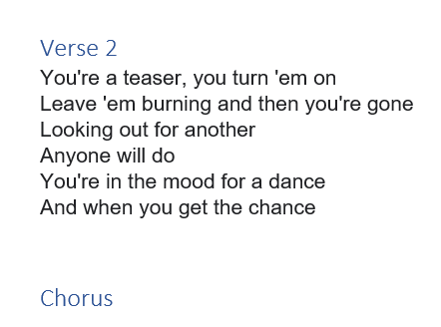
| C | D |
Anybody could be that guy
Night is young and the music's high
With a bit of rock music
Everything is fine
You're in the mood for a dance
And when you get the chance

Chorus
| G | C | G | C |
| G | C | G | C |
You are the dancing queen. Young and sweet, only seventeen
Dancing queen, feel the beat from the tambourine, oh yeah
| D | B | Em Em/D | A/C# |
| C | Am | G | G |
Ooh You can dance. You can jive. Having the time of your life
Ooh, see that girl. Watch that scene, digging the dancing queen

